From the Chief Medical Officer  Dr Michael McBride  Via Kerrsland Surgery | 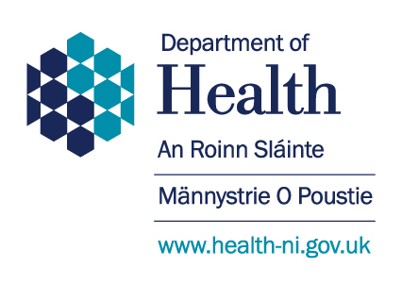
Castle Buildings
Stormont Estate
BELFAST
BT4 3SQ
Tel: 028 9052 0563
Email: Michael.McBride@health-ni.gov.uk
Your Ref:
Our Ref:
Date: June 2020

Dear

UPDATE ON SHIELDING ADVICE

This letter contains an important update on the advice to people who are shielding or who are caring for someone who is shielding.

I am writing to you because you are someone who has been advised to shield, or you are caring for someone who has been advised to shield. We gave this advice to people with certain medical conditions which make them extremely clinically vulnerable to Covid -19.

I know that this has been a very challenging time for you and that it will not always have been easy to comply with the advice.

The Covid-19 virus still poses a high risk if someone who is shielding is exposed to it. However, infection levels in the community are now falling so the risk of exposure is significantly less than it has been over the last two months.

Because the risk is lower, I have now updated the guidance for Northern Ireland so that from 8 June those who are shielding can now spend time outside with people from their own household or one person from another household whilst ensuring that social distancing is observed.

It is important to remember that this guidance remains advisory. You will not be fined or sanctioned if you do not follow the guidance on shielding because you prefer to follow the general guidance on social distancing which applies to everyone.

You may also choose to remain in your own home at all times if you still do not feel comfortable going outside. However, prolonged shielding can have detrimental effects on both physical and emotional well-being and time outside in the fresh air is likely to make you feel better in yourself.

Here is how I have updated the advice:

- If you wish to spend time outdoors (though not in other buildings, households, or enclosed spaces) you should take extra care to minimise contact with others by keeping 2 metres apart.

- If you choose to spend time outdoors, this can be with members of your own household. If you live alone, you can spend time outdoors with one person from another household (ideally the same person each time).

- You should remain vigilant when leaving home: washing your hands regularly, maintaining social distance and avoiding gatherings of any size.

- You should not attend any gatherings, including gatherings of friends and families in private spaces, for example, parties, weddings and religious services

- You should strictly avoid contact with anyone who is displaying symptoms of COVID-19 (a new continuous cough, a high temperature, or a loss of, or change in, the sense of taste or smell).

This updated shielding guidance applies until 30 June. We will provide further guidance before this date.

The advice in this letter does not otherwise affect your status as a person who has been advised to shield. In particular, it does not impact on your entitlement to apply for statutory sick pay. You can find more information on this here: https://www.communities-ni.gov.uk/landing-pages/covid-19-benefits

I know that you will want to know about our plans for the future of the shielding advice. Please be assured that we are actively reviewing the shielding advice and we will provide new guidance before the end of the first shielding period.

As part of this, I am leading a programme of rapid engagement with people who are shielding so that, in considering the future of shielding, we have a clear understanding of the issues you have faced. To start this process, we have launched a questionnaire which you can access at the web address below:
https://patientclientcouncil.hscni.net/.

Alternatively you can contact the Patient and Client Council at info.pcc@pcc-ni.net to receive a paper version which can be posted to FREEPOST Patient and Client Council. Or should you wish to complete the survey over the phone you can call the Patient and Client Council on Freephone 0800 917 0222.

It is important to take care of your mental and emotional wellbeing during this time and we have made some tools available online to help you do this. The Minding Your Head website contains information to help you look after your own mental health and to support others. It contains a directory of mental health services in Northern Ireland, as well as links to online support such as the HSC Apps Library, which provides a range of safe and approved apps for you to download for support with issues such as stress and sleep management.

Free online Stress Control classes are also available for everyone. Each session repeats four times to enable ease of access, with the latest block of classes starting on 8 June 2020. For further information visit: https://www.mindingyourhead.info/

If you are concerned about your mental health and would like to speak to someone, you can talk to your GP, or if you are in distress or despair, you can call Lifeline on 0808 808 8000 where you can speak to a trained counsellor. This service is available 24/7 and is free from all NI landlines and mobiles.

Finally, I wanted to thank you for all of your efforts during this very difficult time. The Covid 19 pandemic has made huge demands on many people across Northern Ireland, and I want you to know that we understand the uncertainty and upheaval that those shielding, their families and carers in particular have faced.

Yours sincerely

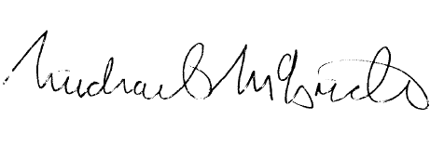

Dr michael mcbride
Chief Medical Officer

